EMERGING TRENDS IN SOFTWARE ENGINEERING
BSE4104
WEEK 3 PROGRESS REPORT
Project Title | CampusConnect: A University Student-Support Agent for CoCIS Freshers.
Week | Context Engineering and RAG
Group | Group A Evening
Team Members
Biira Wishes Tricia | 23/U/07545/EVE
Tusiime Jonathan | 23/U/18245/EVE
Nabasumba Suzan | 23/U/12717/EVE
Makwetta David | 21/U/06093/PS

1. Introduction
The main focus during Week 3 was implementing and evaluating the Retrieval-Augmented Generation (RAG) pipeline for CampusConnect. This involved preparing the RAG architecture diagram, testing the system using student-support questions, and identifying retrieval and grounding failures to assess the reliability of its responses.
2. Tasks Completed
2.1 Development of the RAG Pipeline
The RAG pipeline was implemented to allow CampusConnect to retrieve relevant information from the project's knowledge corpus before generating responses. Rather than relying entirely on the language model's existing knowledge, the system retrieves supporting passages from the corpus register and supplies them as context for response generation.

The pipeline consisted of the following components:
- Document loading: PDF documents in knowledge/Corpus/ were loaded for processing.
- Text splitting: The extracted document text was divided into smaller chunks using the Recursive Character Text Splitter, configured with a chunk size of 1,000 characters and an overlap of 150 characters.
- Embedding generation: The sentence-transformers/all-MiniLM-L6-v2 model was used to convert text chunks into numerical vector representations of 384 dimensions.
- Vector indexing: FAISS was configured to store and search the embeddings for relevant document passages.
- Retrieval: The retriever was configured to return the four most relevant chunks for a given question.
- Response generation: The retrieved context was passed to the Gemini language model, identified in the project configuration as gemini-3.8-flash, to generate a response grounded in the available evidence.
2.2 Preparation of the RAG Architecture Diagram
A RAG architecture diagram was prepared to illustrate the major components and their relationships. The diagram separated the knowledge ingestion process from the runtime question-answering process.
The knowledge ingestion workflow showed how CoCIS PDF documents were loaded, split into chunks, converted into embeddings, and stored in a FAISS vector index.
The question-answering workflow showed how a student's question was received by the CampusConnect application, passed to the retriever, and used to obtain relevant passages from the vector store. The retrieved context was then supplied to the Foundational Model Layer, where Gemini generated a response for the application to return to the student.
The diagram helped document the system design and clarify the roles of the document-processing, retrieval, and language-generation components.
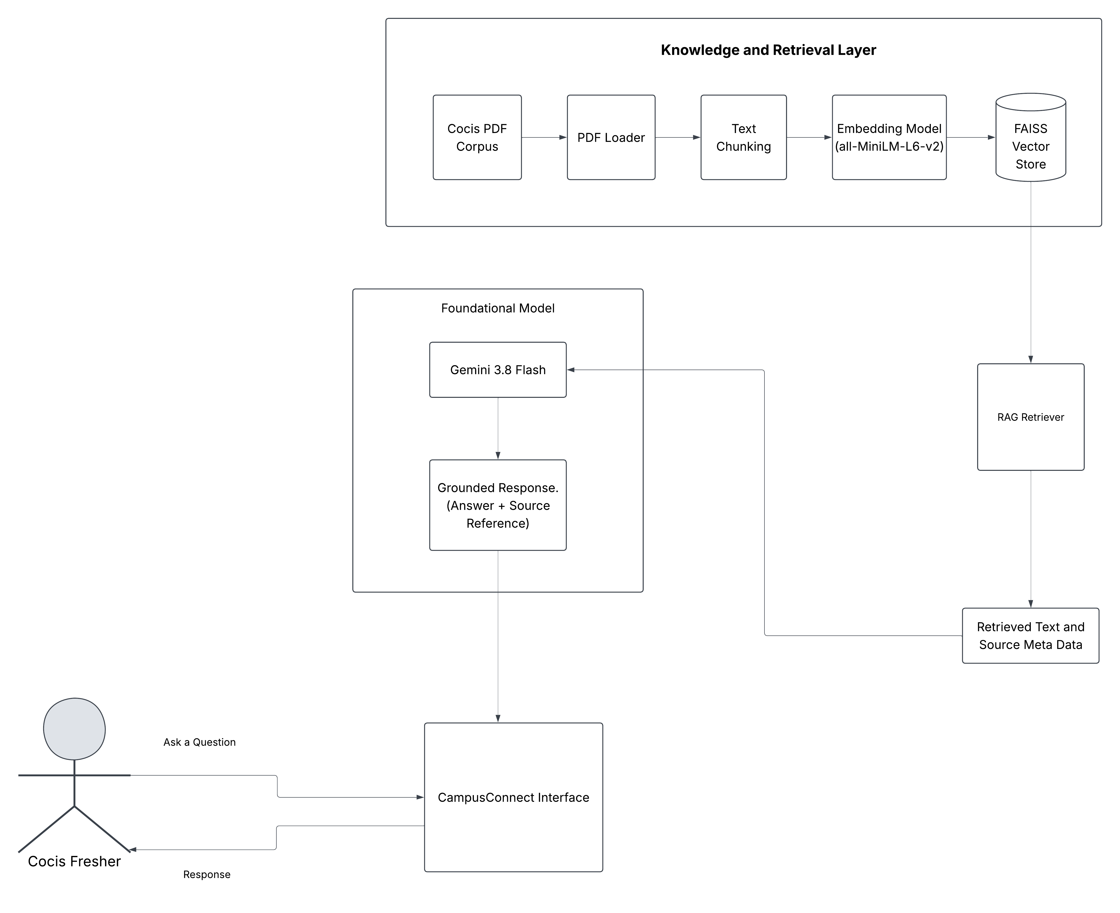
Rag Architecture
2.3 RAG Evaluation
A 15-case evaluation set was prepared to assess CampusConnect's ability to respond to different types of student enquiries. The questions covered CoCIS programmes, facilities, contacts, course registration, tuition fees, application deadlines, timetables, and personal student information.
The evaluation included three categories:
- Answerable questions: Questions for which the available corpus contained sufficient information to support an answer.
- Partially answerable questions: Questions for which the corpus contained some relevant information but did not fully establish the requested answer.
- Unanswerable questions: Questions for which the available evidence was insufficient to provide a reliable answer.
The evaluation considered whether responses were relevant to the question, whether they were supported by retrieved evidence, and whether the system acknowledged uncertainty when information was unavailable.
The results indicated that CampusConnect could provide useful information for several questions, including the full name of CoCIS, available facilities, and some programme details. Other questions, particularly those concerning complete programme listings, current fees, registration procedures, and application deadlines, exposed gaps in the available information.
The evaluation also included questions involving personal student information and future timetables. These cases were intended to assess whether the system could recognize information it could not verify and direct students to appropriate official channels.
2.4 Documentation of Retrieval and Grounding Failures
Three retrieval and grounding failure cases were documented based on the limitations identified during the evaluation.
Failure 1: Incomplete programme information
CampusConnect returned some CoCIS programmes but did not provide a complete list of all programmes offered. This limitation was associated with incomplete programme information in the available corpus or the possibility that relevant passages were not included among the retrieved chunks.
Failure 2: Unconfirmed library location
The available retrieved information did not provide sufficient evidence to confirm the exact location of the CoCIS library. This highlighted the importance of grounding facility-related answers in reliable documentary evidence rather than relying on unsupported information.
Failure 3: Missing course registration procedure
CampusConnect could not provide a complete, confirmed course registration procedure from the available evidence. The limitation was associated with insufficient procedural information in the corpus or the failure to retrieve relevant instructions.
These cases demonstrated why a RAG system must be evaluated not only on whether it generates a response, but also on whether the response is complete and adequately supported by the retrieved documents.

3. Tasks in Progress
3.1 Improvement of Corpus Coverage
The evaluation highlighted areas where the available corpus did not fully support student enquiries. Further review was therefore required to identify authoritative documents containing complete programme information, course registration procedures, and other academic information relevant to CoCIS students.
3.2 Review of Retrieval and Grounding Performance
Further testing was required to investigate whether the identified limitations resulted from missing source information, ineffective retrieval, or insufficient grounding during response generation. This would help distinguish corpus-related problems from retrieval and generation problems before making changes to the implementation.
4. Challenges Encountered
4.1 Incomplete Information in the Knowledge Corpus
Some student enquiries could not be answered completely because the available documents did not contain sufficient information. This affected the system's ability to provide complete programme listings and confirmed academic procedures.
4.2 Retrieval of Relevant Information
The retriever was configured to return the four most relevant text chunks. However, relevant information could still be omitted when it was absent from the corpus or was not ranked among the retrieved chunks. This showed that retrieval settings and corpus quality both influenced the answers produced.
4.3 Verification of Current Information
Some information, including tuition fees, application deadlines, timetables, and academic procedures, required current and authoritative sources. The available documents did not always establish whether such information was up to date.
4.4 Grounding Responses in Retrieved Evidence
The evaluation emphasized that generating a fluent response was not sufficient. The system also needed to ensure that its answers were supported by retrieved evidence and that uncertainty was communicated whenever the available information was insufficient.
5. Lessons Learned
The Week 3 activities provided several lessons about building a reliable RAG-based agent.
First, the quality of the knowledge corpus directly affects the usefulness of the responses. A retrieval pipeline cannot reliably provide information that is missing from its source documents.
Second, document chunking and retrieval configuration influence which information is available to the language model. The relevance of retrieved passages must therefore be evaluated rather than assumed.
Third, source traceability is important for verifying answers. Retaining document names and page references makes it easier to check whether a response is supported by the source material.
Finally, a reliable student-support system must recognize its limitations. When the available evidence does not support a complete answer, the system should communicate that limitation instead of presenting unsupported information as fact.
6. Next Week's Tasks
- Define at least two tools/functions with purpose, input schema, output schema, authorization and failure behaviour.
- Implement tool/function calling through the application/orchestration layer.
- At least one tool should retrieve current application data or perform a low-risk simulated side effect such as creating a ticket/draft record.
- Test missing parameters, unauthorized requests, unavailable services and unexpected tool responses.
- Add human approval before any higher-impact action.
7. Conclusion
Week 3 focused on implementing and evaluating the CampusConnect RAG pipeline. The evaluation identified gaps in the available information and retrieval process, highlighting the need to improve corpus coverage and ensure responses are grounded in reliable source documents.

